I successfully TAP’ed out in March 2025. This is an unofficial guide based on N=1 to help you through the post exam fog and the sprint to the finish line. It’s written for the level I was at around the time of FIMC/TAP- i.e. basic, so bear with me if it all seems a bit obvious.

The official guidance is here: https://www.ibtphem.org.uk/assessment/

Good luck! Any comments, suggestions or further info update PHEMTA via the WhatsApp “current PHEM trainees” group

1: What your ES/training faculty needs to do with you:

1.1 Structured training report form- for phase 1 and 2, this is in the FORMS tab on PHEMnet
1.2 ES meetings- forms are on PHEMnet, beginning, middle and end of placement.
1.3 FEGS- minimum 1 for each phase of training. They should be provided to you- upload them as a reflection on PHEMnet
1.4 ES recommendation- this form is available at the above link but it is an old COVID one, my ES used the even older 2019 one available here: https://www.ibtphem.org.uk/media/1118/tap-es-recommendation-2019.docx which was accepted. As off 23/6/25 I cannot see an updated version but worth checking before you submit.

2: What you need to do:

2.1 Go to https://www.ibtphem.org.uk/assessment/ for the necessary forms
2.2 Complete TAP checklist- Here is how I completed my TAP checklist- filename refers to what I saved it as on PHEMnet, upload it as a reflection.
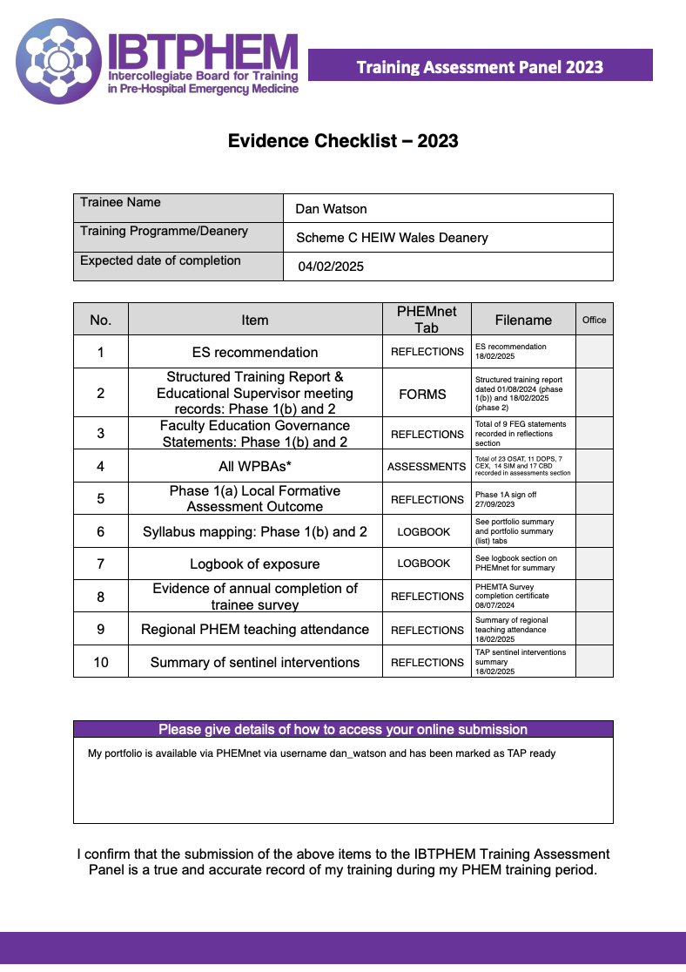

2.3 Checklist detail:
If you’ve been using PHEMnet then this is actually relatively easy- which I’m sure you can appreciate is not often said about PHEMnet…..
- ES recommendation, see section 1.4
- STR and ES meetings, see section 1.1 and 1.2
- FEGS, see section 1.3
- WBPAs -20 OSATS is the minimum requirement 10 phase 1, 10 phase 2 showing progression to level 4. I did 23 in total and to my knowledge none were rejected by the TAP panel. I cannot find any post TAP comments in the “TAP comments” tab on PHEMnet for any of them. Below is a fair representation of the median of my OSATs- I generally completed a full timeline on the first page and usually I ended up filling in most of the components section but this is what I would usually get back in the components and NTS sections. While formal guidance suggests they need to be fully filled in it seems that the grade section is the most important. So if you have some more blank ones at this point in the year just make sure they are as complete as you can get them, especially the grading and do a few extras.
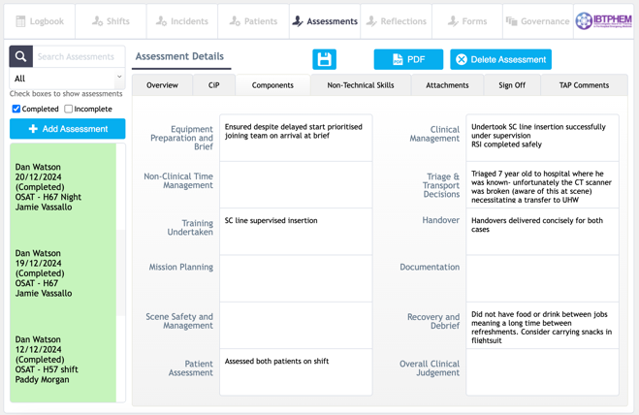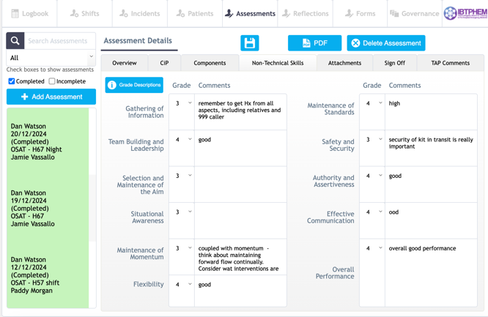

- Phase 1a sign off, upload a certificate to reflections section of PHEMnet, your service/ES/TPD should be able to provide this if you don’t have it already
- Syllabus mapping- You find this in the logbook tab on PHEMnet. As part of my final ES meeting/STR/ES recommendation meeting my ES went through the portfolio summary (list) tab in the logbook section (see below) and checked I had something for each CIP in phase 1 and 2 based on the date and covered that in their ES reports. Take a look through yours yourself and if you’re short do a reflection to reference any gaps- you can’t use FIMC result to reference the whole curriculum though apparently!
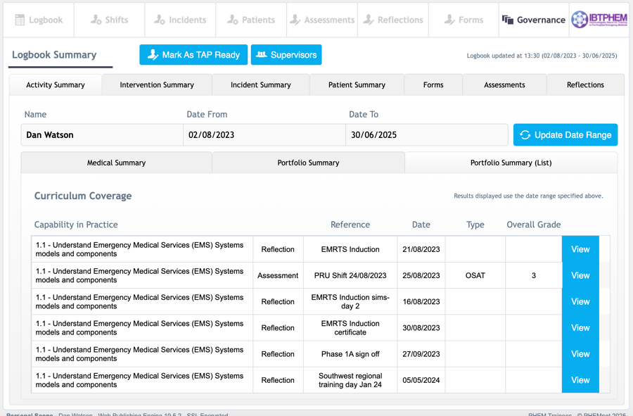
The portfolio summary tab (see below) will give you an overall indication of coverage, over 95% you should be fine. I just referenced my PHEMnet portfolio in the checklist for the syllabus mapping section for TAP and relied on what my ES had written in their reports as I see no other way of demonstrating this.
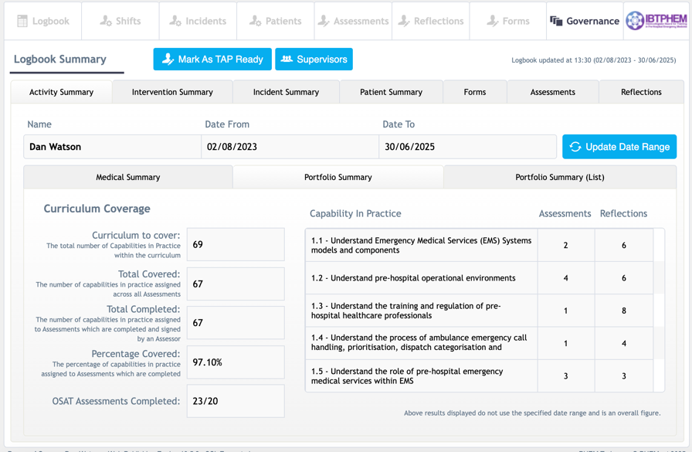

- Logbook – if you’ve been logging interventions on PHEMnet just reference your portfolio, otherwise upload your personal log as a reflection
- PHEMTA survey - upload your certificate of completion as a reflection- contact PHEMTA urgently via the WhatsApp group if you still need to complete this.
- Regional PHEM training- complete a summary and upload as a reflection. Here is what I did, you could include the national obstetric training day, exam prep courses and the induction course as well
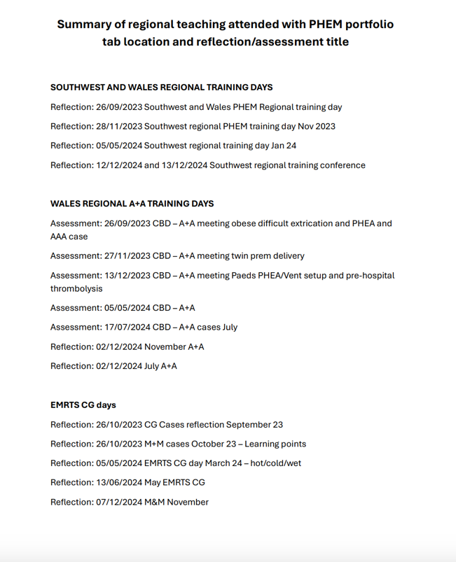

- Summary of sentinel interventions – this is much about quality assurance of training as it is about you. There are no minimum numbers. Complete the summary of sentinel interventions form from the link in 2.1. This is how I completed mine:

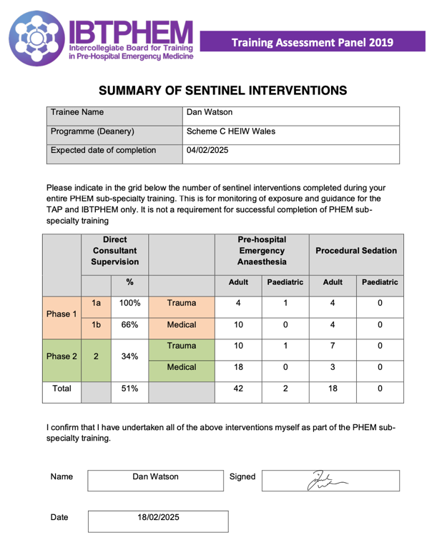
To easily get these numbers, if you use PHEMnet and have been recording your patients on it, go to the logbook tab and change the date range to your phase 1a,1b and 2 dates in turn, this will give you your direct supervision % so long as you have completed your shift logs and named the consultants you were working with. Then click on the intervention summary tab for each date range and you will get your numbers of interventions per phase
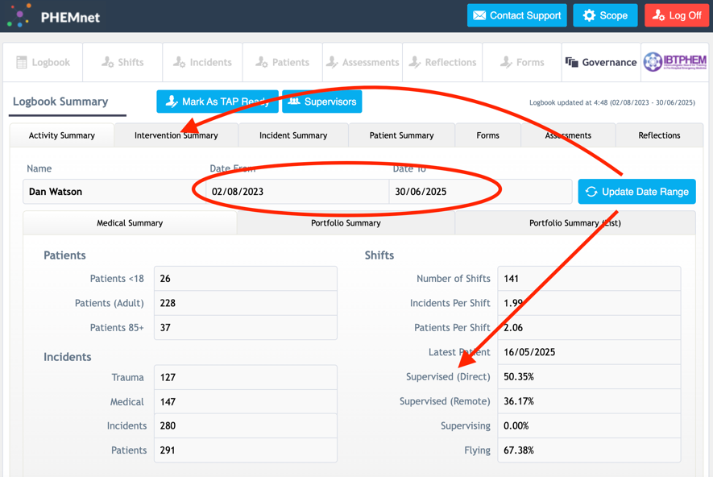

In addition to the TAP checklist:
2.4 Upload your phase 1 and phase 2 MSFs (minimum 14 respondents) as reflections, however, these are reviewed by your ES and recorded in their supervisor reports.
2.5 Upload your exam results letter (if available), there is a drive to get results out before TAP as it means they don’t have to reconvene after results to give outcome A to people who pass. You’d hope they would know your result but make it easy and clear and upload you results letter as a reflection.
2.6 Mark your portfolio on PHEMnet as “TAP ready” you should receive an email from PHEMnet confirming this has happened, if you don’t get in touch with PHEMnet on support@phemnet.org
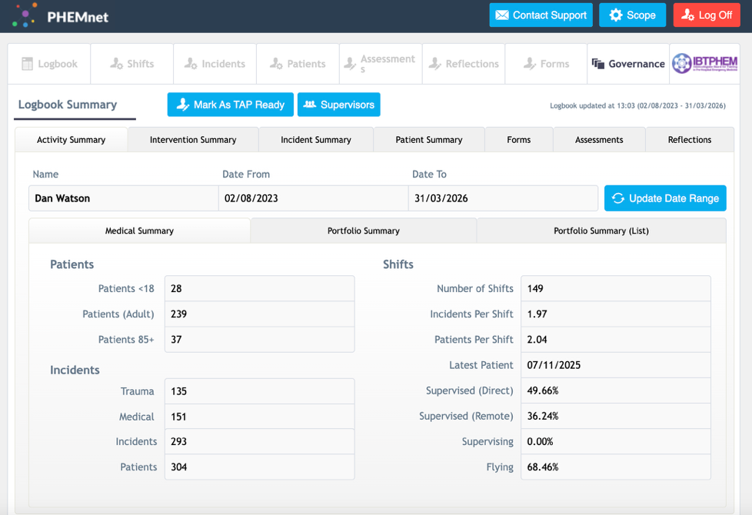

TAP FAQS
Q- Can the portfolio be unlocked after pressing “mark as TAP ready”?
Yes, contact support@phemnet.org
Q- My consultant is on holiday and hasn’t done my OSAT, can late submissions be considered after pressing “mark as TAP ready”?
Yes, but these should be approved by your ES/TPD/Training committee lead- contact them directly
Q- Can the TAP panel see unsigned stuff?
Yes, unsigned assessments and reflections are visible to the TAP panel

